IMMC 2023 Winter Round—Problem E
Team Control Number: IMMC23005957

- Summary
In the biological field of science, species often bear similar traits with each other in which can make them hardly identifiable from each other, which proves a problem when biologists need to conduct research on one specific species only. Even though there are existing methods such as DNA testing that can identify the difference between 2 similar species, the time it takes ranges from 3 to 8 weeks, and can prove to be inconvenient and inefficient when there is need for speedy prediction. This obstacle forms a lag between discovery and research, and will affect the collecting of new data about the biosphere. Therefore, we take the example of the genus Darevskia in order to formula a set of algorithms which can help us to predict the species that the lizards belong to with the highest possible accuracy.
During the initial conceiving of our plan, we devised 3 methods which we thought could be utilized to construct our algorithm. The first one is to, through displaying the provided numbers onto scatter graphs, detect the patterns and find the correlation of those patterns with the tasks. However, when the graphs were made, we realized that most of the statistics yielded no real meaning as most of the ranges overlapped heavily and did not feature any major differences. We saw that the variables were not too varied for species and gender, so this proved a challenge as we later on plan to maximize the difference. Second, we also planned to use trial and error with our program, but in the end the results turned up too much possibilities in generating the function and h value. Our third initial strategy was to explore all available combinations of functions and h value, but in the end the obstacle to this was that we did not have a specific way to create the corresponding function, so in the end this was also discarded.
Moving on to the formulation of our algorithm, we used 3 main methods which were effective and feasible in helping us accomplish the tasks given.
Firstly, instead of only analyzing the difference between the ranges of the variable values on the surface value, we decided to use addition and multiplication with multiple variables in order to increase the difference instead of analyzing it simply. This allowed us to see the results more clearly. Second, we developed a set of code that, after improvement, was verified to be able to try the h value, which let us be able to continue our further steps. Lastly, we used a more systematic way of trial and error by inserting each given variable into our function and noting the results. If, after plugging in the variable, there is no change in the result than the initial one, then we would remove the variable to be deemed as unapplicable to the specific function. However, if the inserted variable does negative work upon the final percentage, we would place it to be subtracted in our final function.
With those above methods in mind, we were able to make our way through the 5 tasks assigned and produce a set of criteria that is the most fitting and concise for the provided situation, finally becoming able to predict the biological species and sex of the lizards with the best possible accuracy.

Table of Contents
II. Introduction 3
III. Defining the problem 3
3.1 Question restatement 3
3.2 Assumptions and Justifications 4
3.3 Variables 4
IV. About the Algorithm 5
4.7 Challenges 15
V. Strengths 15
VI. Weaknesses 15
VII. Conclusion 15
VIII. Appendix 15

Introduction

In the biosphere, there are countless species which bear similar physical characteristics with each other, and this has posed a challenge for biologists as there is still no 100% perfect way to determine the species the specific organism belongs in in a short amount of time. This kind of biodiversity, commonly referred to as “cryptic biodiversity”, is often a challenge to biologists when they encounter new species or desire to know the relationship between two organisms of nearly identical physical organisms. Since even animals within a same species can bear different measurements (from different amounts of nutrients intake, habitat, resource availability, etc.), there is yet no set of algorithms which can predict the animal species purely based upon the relationship between measurements of the organism.
Such is the problem that exists within the genus Darevskia with 8 species of lizards. Therefore, in this problem, by analyzing the given data, we can identify the correlation of characteristics and produce a set of algorithms that can predict the species that the lizard falls into with the highest possible accuracy rate.
However, before explaining the solution, we will begin first by restating the problem.

Defining the problem

3.1 Question restatement
We are given a set of data entailing the pholidosis and morphometric characteristics of 564 lizards belonging to 8 species of the genus Darevskia. Then, with those numbers, we are then expected to develop a set of criteria that will be able to predict the biological species and sex of the lizards. The set of criteria should attempt to meet the following conditions as best as is feasible:
- Differentiate lizards of species #5 from all other lizards using only FPNr
- Differentiate lizards of species #5 from all other lizards and uses two variables out of the measured morphometric and pholidosis characteristics
- Predict lizards’ sex regardless of their biological species on the basis of the morphometric and/or pholidosis characteristics.
- Differentiate all species within the following groups:
  - species #6 and #7,
  - species #1 and #2,
  - species #3, #4, and #5
- Predict lizards’ species or species and sex in their entire population
Given these objectives, we can begin laying out the assumptions and variables we need to account for and define.

3.2 Assumptions and Justifications
While designing our model, we decided on several basic assumptions to simplify the question. Listed below are the assumptions and our justifications for them.
Assumptions | Justifications
The data provided for us accounts for the outliers | This assumption is made because it will allow for a generally more realistic take on the problem, acknowledging that there are exceptions in the natural world.
The data provided does not contain any counting error or measurement uncertainty | We make this assumption to let the processing of data more convenient, and it is difficult to estimate the percentage in which there will be occurrence of counting error

3.3 Variables
Since most necessary variables have been define already in the data set provided, we will only include the most important variables and those we use in our model in this table below.
Variable | Definition
HL | head length, measured ventrally from the tip of the snout to the posterior margin of the collar
PL | pileus length measured dorsally from the tip of the snout to the posterior margin of the parietal + occipital scales
HW | width of the head before the tympanic hole
HH | head height near the occipital plate
MO | mouth opening, measured laterally from the tip of the snout to the end of the mouth
FFL | total forelimb length, from the base to the tip of the longest toe
HFL | total hindlimb length, from the base to the tip of the longest toe
SCGr | number of superciliary granules on the right of lizard
VSN | ventral scale number on the middle line
SVL | snout-vent length, length of the body from tip of snout to cloaca
TRL | trunk length (from the groin to the armpit)
FPNr | femoral pore number on the right side of lizard

About the Algorithm
4.1 Overview
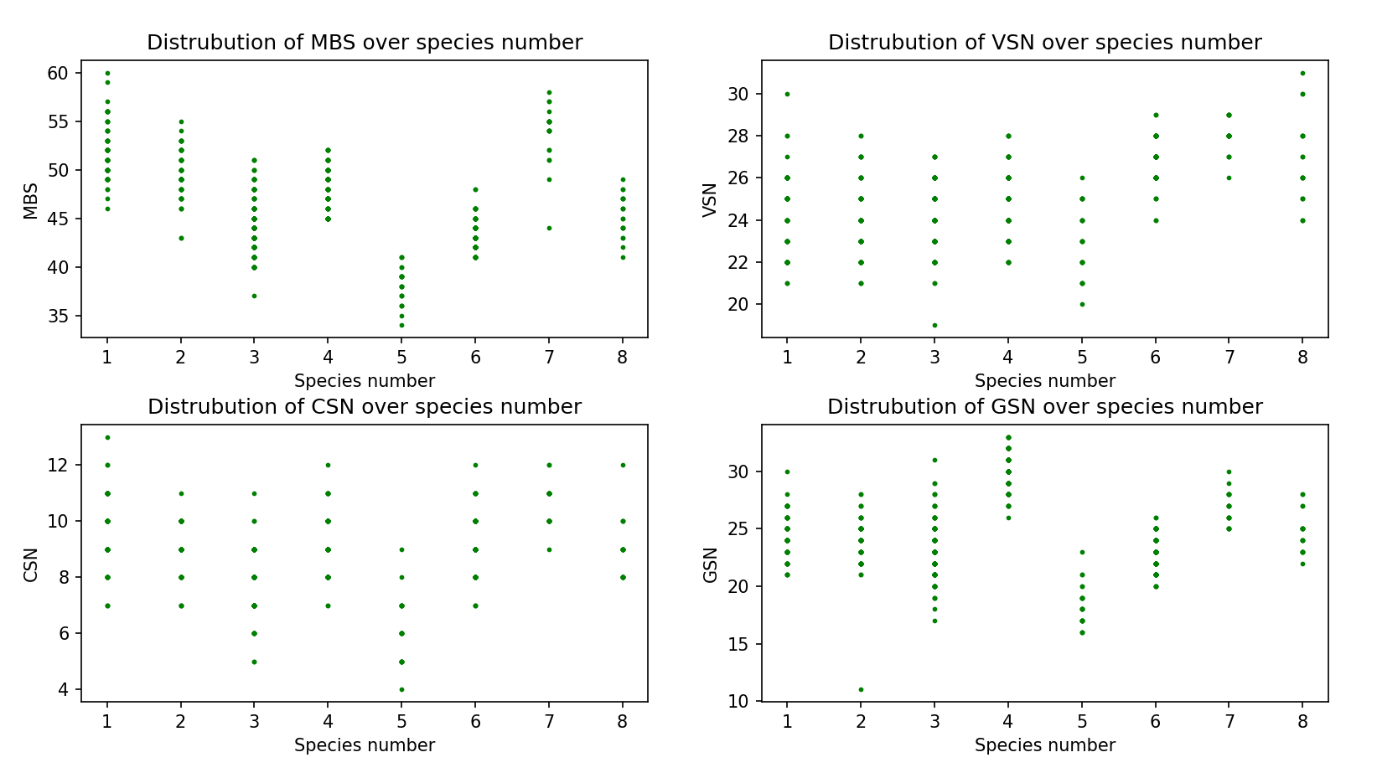

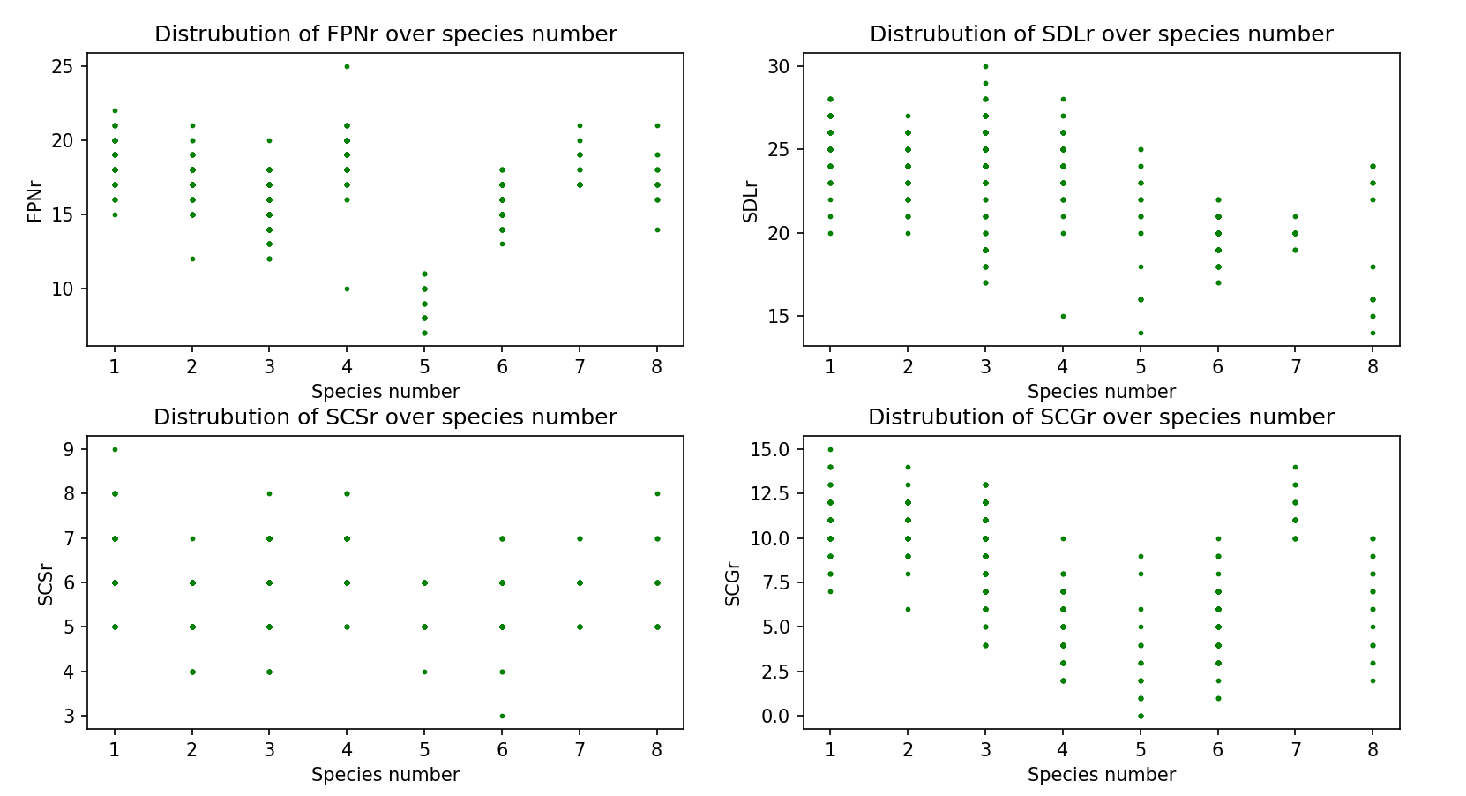

As shown above, the images are graphs that represent the relationship between the species number and the variables. The green points represent the variables labeled green in the data set (from MBS to aNDSr), while the orange points represent the variables labeled orange in the data set (from SVL to HFL). The graphs were created using the matplotlib module of python, in order to manifestly exhibit outliers for inspection.
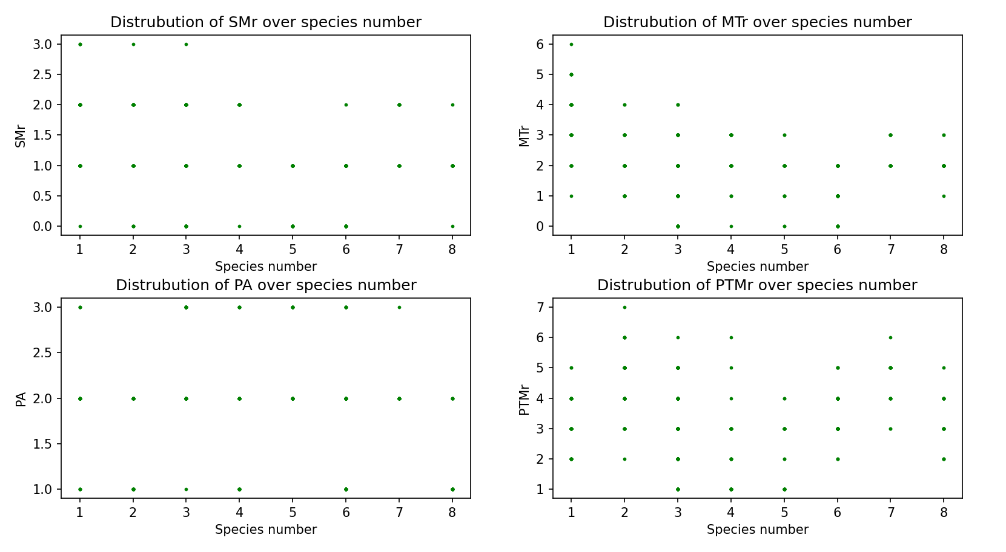
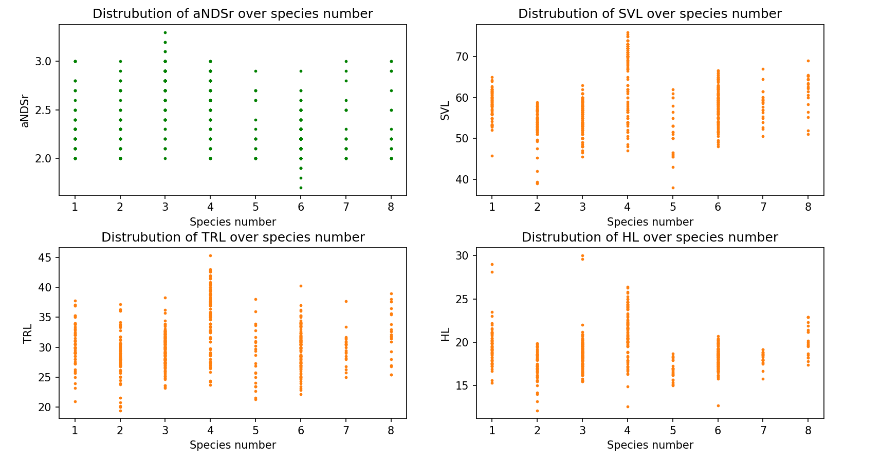
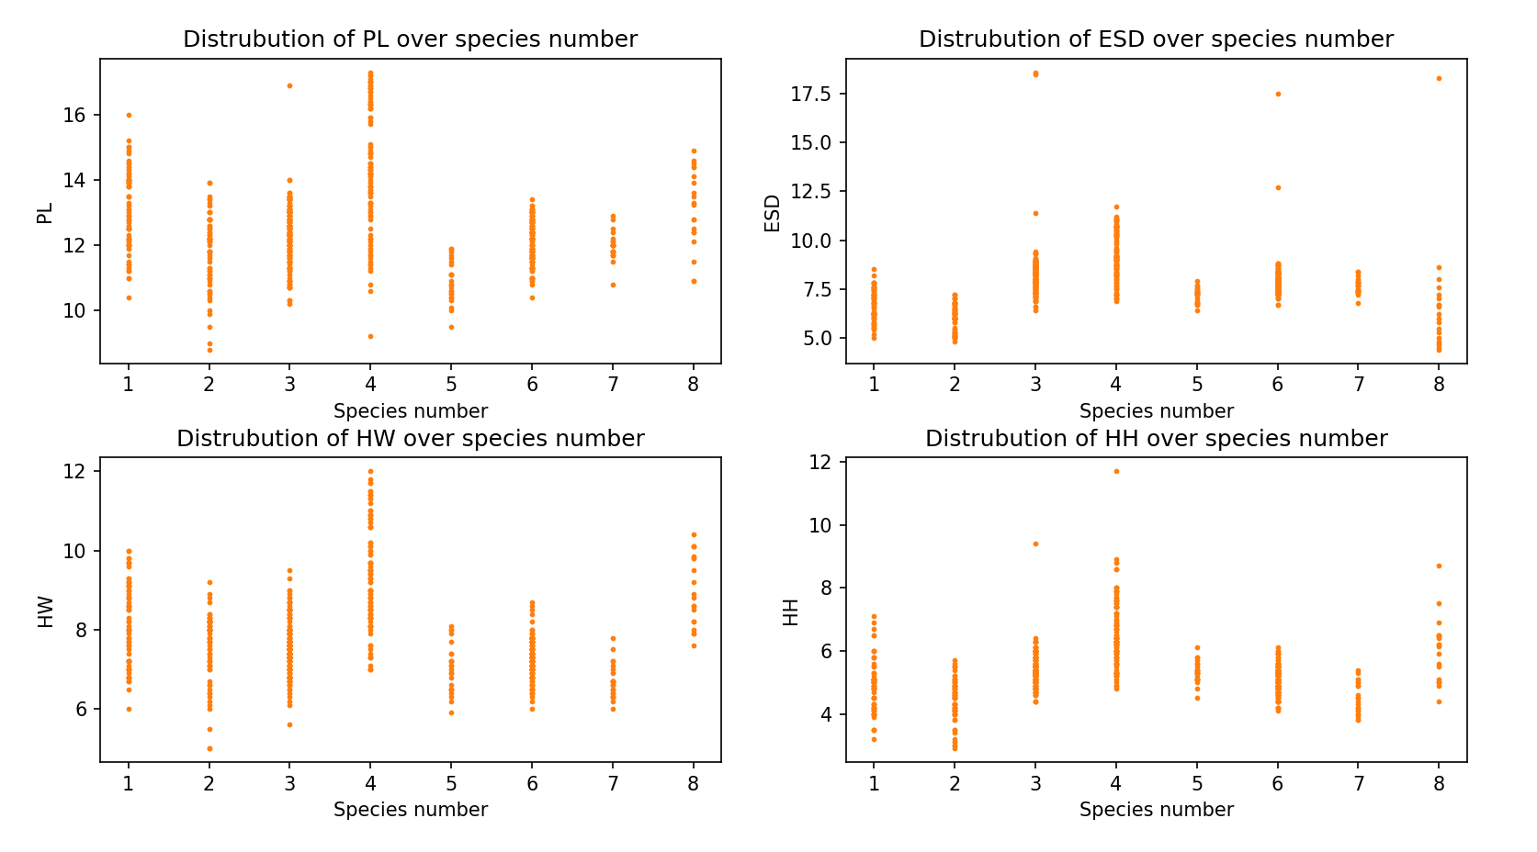
All the graphs are necessary for further inspection in tasks 1-5, as they provide different trends useful for distinguishing among species. By creating such visuals, the problem will be simplified and we would be able to create our model more efficiently.
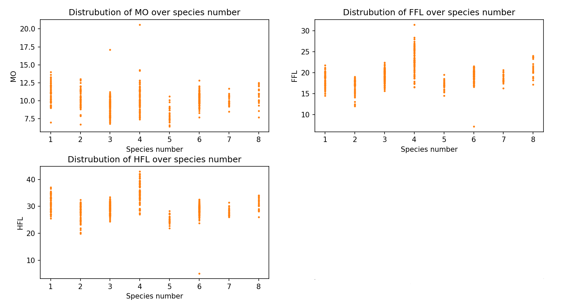
There are in total 564 sets of measurements, so to allow for a primary visualization of the statistics and further comparison, we have generated scatter graphs instead of simple line graphs to categorize the provided data, as shown above. These will be the graphs in which we will be referencing to afterwards.
With this in mind, we can continue onto the analysis and solution of the tasks.
4.2 Task 1
Firstly, to be able to effectively compare the difference of range between the different species within the genus of Darveskia, we displayed the given statistics into a scatter graph to have a general overview of the range of FPNr of each species. And as shown on the graph on figure 1, we can observe that species #5 shows a range that is significantly lower than the other 7 species, with its FPNr value being $7≤FPNr≤11$.
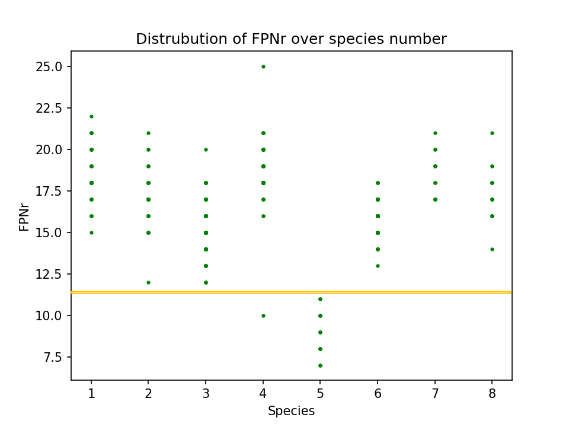
Figure 4.2.1: Difference of species #5’s FPNr among all species of Darveskia

The range of species #5 almost has no overlapping value with the others, except for one outlier from species #4 of a number of 11 scales, so by first (we will afterwards acknowledge this exception) excluding this outlier we calculate the range in which species #5’s FPNr. Therefore, as long as the FPNr value is less than or equal to 11, the species will most likely be of a lizard from species #5.
Then, we move on to the probability of whether or not the chosen lizard whose FPNr is smaller than or equal to 11 is actually one belonging to the #5 species. Since there are in total 25 points (each point representing one lizard) on the scatter graph under the yellow line, and 1 point being the outlier from species #4, the accuracy of the range would be 24/25, yielding a result of 96%.
 | True species #5 | True species #1-4, 6-8
Classified as species #5 | 24 | 1
Classified as species #1-4, 6-8 | 0 | 539

In conclusion, a lizard chosen at random from the group of 564 lizards would be from species #5 if its FPNr value is smaller than or equal to 11, with an accuracy of 96%.

4.3 Task 2 (needs revision)
We can observe from our work in the first task as well as the graph of FPNr that all lizards with fewer than 11 femoral pores on their right belong to species #5, with the exception of an outlier from species #4. This allows us to easily ignore all of the other species save for species #4 in our second variable.
Our group decided to use HFL as our pholidosis characteristic as it is able to differentiate species #5 from the outlier in species #4, which has a hindlimb length of 42.1 millimeters, compared to the longest within samples from species #5 at 28.3 millimeters. Although other species of genus Darevskia also have individuals with HFL within the range from 21.9 to 28.3 millimeters, the main reason our group utilized this morphometric characteristic is because it can be used in conjunction with FPNr to distinguish species #5 from all other species within the data set.
Although HFL is able to differentiate species #5 from the outlier, it creates new problems as HFL does not easily differentiate then FPNr. Using function FPNr + HFL results in a lower accuracy then the function FPNr.
The solution to the lower accuracy is to lower the proportion of HFL. We tried the new equation FPNr + HFL/10, and its accuracy finally reached 100% when h = 14.
$$f\left(FPNr, HFL\right)= FPNr+\frac{HFL}{10}$$
Performance metrics | True species #5 | True species #1-4, 6-8
Classified as species #5 | 24 | 0
Classified as species #1-4, 6-8 | 0 | 540

Originally, however, our group planned to use MBS as the pholidosis characteristic, as it contains similar advantages to calculation in comparison to FPNr: it easily differentiates organisms from species #5 from all other species provided with the exception of a portion of organisms belonging to species #3 and #6. Unfortunately, none of the morphometric characteristics were able to simply and clearly distinguish species #5 and #3, meaning that we were unable to filter out the cases within the range of 34 to 41 medium body scales that belonged to species #3, lowering our accuracy by a significant amount and forcing us to ultimately abandon our use of MBS and switch to FPNr.
As shown in the graphs above, the amount of overlapping of the points of species #5 and #3 in FPNr was less than that of MBS. FPNr was able to clearly differentiate species #5 from our experience in the first task.
4.4 Task 3
At first, our group decided to attempt using individual variables and ranges to solve the task assigned. For example, we knew that lizards with their FFL values greater than 24 were mostly male, so we composed inequality FFL > 24 to determine the approximate boundary between female and male lizards. Our original intention was to combine a number of these inequalities into a single function, but we eventually realized this was unfeasible due to the low number of cases we were able to successfully predict using this method. This led us to realize that we had to be able to combine different variables together in order to extract more information than each one contained individually.
Afterwards, our group decided to conduct exhaustive research in solving this problem to find the optimal variables in which to include within the function. By comparing the averages of the female and male characteristics that were included in the datasets, we were able to come to the understanding that some of the morphometric characteristics bore significant differences between the two genders: SVL and HVL. The importance of these variables was later confirmed in our testing using our python program.
On the basis of these two variables, we attempted to add other variables to see if there were measurable improvements in our results. In our testing we realized that there were two pholidosis characteristics with noteworthy variation between the two genders, VSN and SCGr. However, we realized that there were no other differences in scale arrangements that were able to improve our accuracy. We tested every characteristic provided within the dataset by including it within our program and testing if it increased the number of samples of data that we were able to classify successfully. Those that decreased or had negligible impact on our success rate were eliminated.
Using this method, our final variables became: SVL, TRL, HL, PL, HW, HH, MO, FFL, HFL, VSN, and SCGr. By subtracting the characteristics in which females had larger values, we were able to magnify the difference in the final value between females and males, allowing us to more successfully differentiate between the two sexes.
After deciding the variables necessary to keep in order to improve our success rate, we had to decide on a value with which to define the border between male and female to maximize the amount of correctly determined cases. At first, we planned to use the averages of male and female values and find the midpoint of these two averages, but we realized that this was not the most efficient value. To solve this issue, we modified our program to test all values in a reasonable range to see which would provide the most satisfactory result. Finally, after great amounts of trial and error, we obtained a value of -26 with a success rate of 94.3%, resulting in the function below:
$$2×HL+PL+2×HW+HH+MO+FFL+HFL+SCGr-3×VSN-SVL-TRL>-26$$
If this inequality holds true, the lizard should be a male; otherwise, the chosen lizard would be female. Testing this criterion against the database gives the following results.
Performance metrics | Correctly Identified | Incorrectly Identified
Male | 271 | 4
Female | 261 | 28
The inequality was the result of trial and error by a python program. Since an easy function with only simple operations could achieve an accuracy of 94.3%, we decided to use this simple model that can be understood by all people instead of using a more complex model. This can make the code become easier to be applied. All code used in this section can be found in the appendix section.
4.5 Task 4
a. Part 1
Section one of task 4 requires us to design a criterion that can be able to differentiate species #6 and #7. Since MBS and SCGr already feature high accuracy (as shown in the graphs from 4.1, the two variables only have a small number of points that overlap with each other). Our calculation showed that the two variables each attained an accuracy of about 99%. However, we decided to make the accuracy 100% since it could ensure the success rate of our final algorithm and will be able to produce the best results. In view of the fact that both variables had high accuracy, we combined the two variables by multiplication to remove the error.
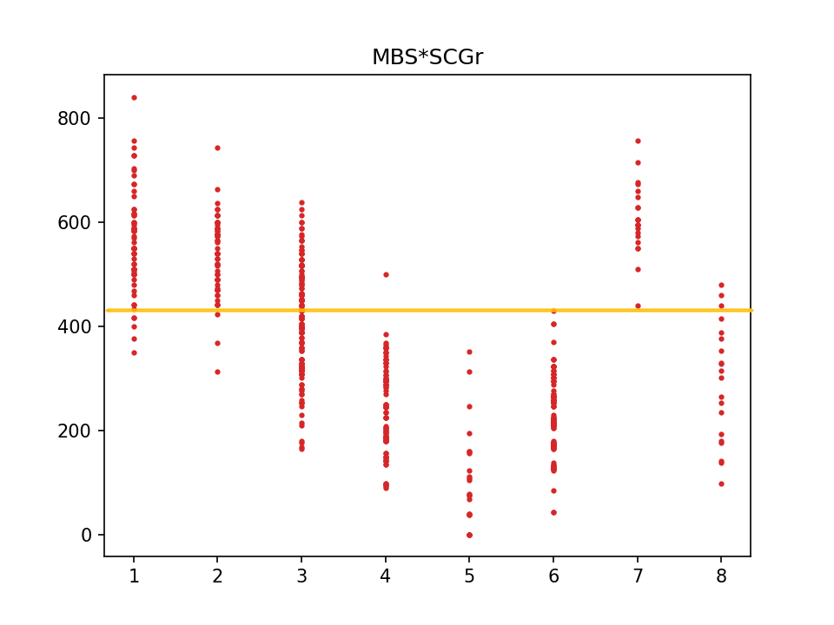
Figure 4.4.1: The results of species 6 and species 7 can be clearly identified.

At last, by covering each possible value of the demarcation point, we ended up with the function:
$$MBS×SCGr<431$$
The species is most likely to be species #6 if the inequality holds. Otherwise, it would belong to species #7. This elementary equation achieves 100% accuracy (with its results exactly identical to those provided in the dataset). The data is from our equation is shown in the following table:
 | True species #6 | True species #7
Classified as species #6 | 120 | 0
Classified as species #7 | 0 | 22

b. Part 2
In part 2, we are asked to build a criterion that can differentiate species #1 and #2. Similar to task 2, we decided to utilize thorough search in order to find the suitable variables for our final function. However, since the dataset showed most of the variables of species #1 to be greater than those of species #2, we decided to use multiplication to enlarge the difference. As the variables are multiplied, the difference between results increased as the interval expanded faster by multiplication compared to addition.
Since observing the graphs only by eye and intuition is both inaccurate and unreliable, we used a program to automate and test all combinations of variable products. Nonetheless, combining several variables and testing their results’ accuracy is time-consuming as the complexity of the algorithm of the program is exponential. In our program, the accuracy of a certain function is calculated by trial and error—our program goes through every integer between the minimum and maximum values of the product of the variables, and finds the value with the highest accuracy. To decrease the amount of calculation and time of processing the data, we decided to analyze the results in pairs (by multiplying every combination of two variables). After inspecting the results, we can determine which variables have a great effect on the accuracy, and therefore we can filter out useful variables and combine them into an optimal function.
After large amounts of attempting, investigating and transfiguring, we discerned the most functional variables to be SCSr, PA, MTr, HL and HFL. Shown in the graph below are the results of multiplying the five variables. The differences in the results of species #1 and #2 are conspicuous, and the calculated accuracy of our function is about 93.0%.
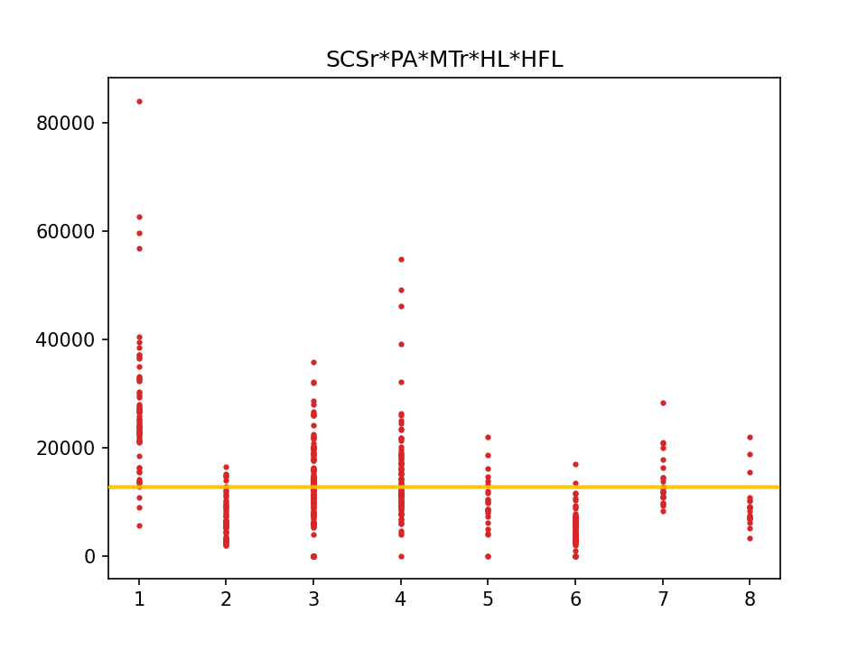
Figure 4.4.2: The relationship between species number and the results of multiplying the five variables

With further calculation, we can get the final result:
$$SCSr× PA× MTr× HL×HFL>12701$$
If the inequality holds true, then the species is most likely to be from species #1. Otherwise, the species should be from species #2. The value 12701 was calculated by traversing every value within the possible range. Our program verified that 12701 had the highest accuracy with 93.0%, meaning that this demarcation point differentiated the species correctly for about 93% of the time.
Performance metrics | True species #1 | True species #2
Classified as species #1 | 63 | 6
Classified as species #2 | 3 | 57

In comparison with the fact that complex algorithms both require large amounts of evaluation time and are perplexing, we chose an intelligible model using only multiplication. The five useful variables SCSr, PA, MTr, HL and HFL all show the pattern that species #1 has a larger value than species #2, therefore the simplest way (and also best) way to combine them is to multiply them.
c. Part 3
Task 4, part c involves differentiating multiple species from each other. It is not ideal to separate the three species in one equation, however, so we decided to use a piecewise function to sort out the different species.
The first condition of the piecewise function is to separate species #5 from species #3 and #4. This question is already accomplished in task 1, where we were able to use the pholidosis characteristic FPNr to differentiate species #5 from all other species. Using information from task 1, we can derive the first inequality:
$$FPNr≤11$$
The following question that needs to be solved is the matter of identifying the difference between species #3 and #4. By analyzing the scatter plots that display the provided data (shown above in 4.1), we found a great portion of overlap presented in the graphs between species #3 and species #4, with the pholidosis characteristic of GSN featuring the least amount of overlap. This theory is tested through code, and later verified. We then loop through the values of h about GSN, finally finding the best value of h to be 26.1, therefore allowing for the inequality:
$$GSN<26.1$$
Combining the two functions into one, we get the final function:
$$f\left(FPNr, GSN\right)\left\{\begin{aligned}FPNr≤11 5 \\ FPNr>11 and GSN≥26.1 4 \\ FPNr>11 and GSN<26.1 3\end{aligned}\right.$$
In conclusion, ff the lizard’s FPNr ≤ 11, it is species #5; if it is FPNr > 11 and GSN ≥ 26.1, it is species #4, otherwise it is species #3. Testing this criterion against the database produces the following results.

Performance metrics | True species #3 | True species #4 | True species #5
Classified as species #3 | 146 | 1 | 0
Classified as species #4 | 10 | 91 | 0
Classified as species #5 | 0 | 1 | 24

The accuracy of the criteria is 95.6%.
4.6 Task 5

4.7 Challenges

Strengths

Strength1: Our model features a high level of accuracy with most of the tasks being able to predict the species at an accuracy rate of more than 93% most of the time. This means that our set of criteria are highly applicable to real life and is actually effective in predicting the species of the lizard, so our model is successful in achieving the requirements.
Strength2: Our model only involves simple mathematical operations (addition, subtraction, multiplication and division) instead of superfluous equations, which makes the criteria lucid and easy to comprehend. Our model uses the easiest possible operations and the function might not even require a scientific calculator to be calculated. This lets the criteria be more convenient to be used in real-life situations, and therefore more realistic.

Weaknesses
Weakness1: We utilized many variables for each criterion, so this may mean that during the actual collecting of data (for each corresponding variable), this process may take up quite some time in order to achieve accurate measurements. However, we must acknowledge the fact that even if the measurement of values does take up a lot of time, the time range would still be shorter than the time range for DNA testing (3-8 weeks). Therefore, our criteria are still useful in helping biologists predict the sex and species of a particular lizard.
Weakness2: We did not use the standard way of splitting the number of variables into two halves and combining them due to our inability to find conditions under which this would be feasible. To make up for this flaw, we had to go through with more complex steps, which made our solution less efficient, but on the whole, this does not affect our criteria in a big way.

Conclusion

- Reference

admin. “DNA Testing for Your Pet.” Blue Cross Veterinary Hospital, 1 Jan. 2022, bluecrossvethospital.com/dna-testing-for-your-pet/. Accessed 17 Jan. 2023.

Beheregaray, Luciano B, and Adalgisa Caccone. “Cryptic Biodiversity in a Changing World.” Journal of Biology, vol. 6, no. 4, 21 Dec. 2007, p. 9,
www.ncbi.nlm.nih.gov/pmc/articles/PMC2373901/, 10.1186/jbiol60.

Stover, Dawn. “Animals That Look Alike but Aren’t.” Popular Science, 19 Dec. 2001, www.popsci.com/scitech/article/2001-12/animals-look-alike-arent/. Accessed 17 Jan. 2023.

Appendix

